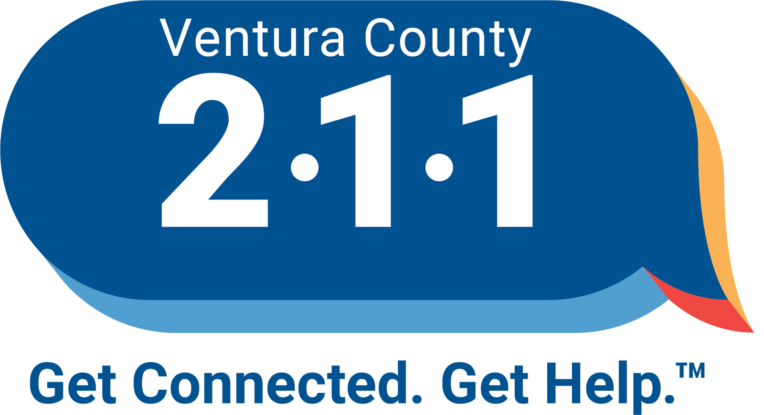
211 Ventura County
Inclusion / Exclusion Policy

211 Ventura County provides comprehensive information and referral services, linking residents to health and human services in our community. The following guidelines are used to determine if an organization is eligible to be listed in the 211 Ventura County community service directory.

The following criteria MUST be met to be in order to be considered for inclusion in the 211 Ventura County community service directory. (MANDATORY CRITERIA)
- Organization provides a health or human service for residents of Ventura County.
- Organization must demonstrate provision of service for at least six months.
- All organizations included in the 211 Ventura County community service directory must agree to update their service information, at minimum, once each year.

Organizations meeting the following criteria are eligible for inclusion, provided they meet all mandatory criteria above and do not meet exclusion factors below.
- Government (local, state, federal) agencies that provide social, consumer, criminal justice, education, legal, environmental or other services to residents of Ventura County.
- Non-profit organizations that provide social, educational, legal, community, consumer, health or human services to residents of Ventura County.
- Local elected representatives.
- Churches, social clubs, service organizations, and civic groups that offer a service to the community at large.
Organizations meeting the following criteria may be considered for inclusion provided they meet all mandatory criteria above and do not violate any exclusion factors.
- For-profit organizations providing health or human services not adequately available from the non-profit sector are considered on an individual basis.
- Support groups that are not part of a larger agency that do not charge a fee for service and can demonstrate provision of service for at least six months.
- National organizations and out-of-county entities, including statewide and national toll-free phone services, that offer needed health and human services and which address a gap in local services or in the case where the out of county service is more accessible to residents than the equivalent services offered within Ventura County.
Organizations meeting the following criteria will not be included in the 211 Ventura County resource database.

- Any organization which promotes or delivers illegal services.
- Agencies that misrepresent themselves, fail to respond to updating contacts or deny service based on prejudice or discrimination.
- Services which are available only to members of a certain group or affiliation. For example, counseling available to a church’s parishioners only.
- Organizations that offer free or low-cost services as a way to market the organization’s main business when the organization’s main business/services are not appropriate for 211 inclusion.
- Private practitioners or group practices of mental health providers, medical doctors, dentists, legal/paralegal providers, etc.
- Providers serving the childcare needs of the county as Ventura County 211 has an agreement with Child Development Resources of Ventura County to handle all referrals for child-care requests.
- Volunteer recruitment and coordination organizations will not be considered as Ventura County 211 has an agreement with United Way Ventura County to handle all volunteer related referrals.
Guidelines for Review and/or Appeals
Should special circumstances exist which are not effectively covered by the preceding guidelines, or if there is disagreement about inclusion or exclusion, the agency or organization in question may contact 211 Ventura County and request a review of the inclusion/exclusion decision.
Disclaimer
Eligibility for inclusion does not guarantee inclusion. Inclusion in the 211 Ventura County community service directory does not imply endorsement and omission does not indicate disapproval.
211 Ventura County may exclude or remove organizations from the 211 Ventura County resource community service directory at any time at the discretion of the 211 Ventura County Resource Department. Exceptions to this policy may be made at the discretion of the 211 Ventura County Resource Department.
This policy does not prohibit the inclusion of any program that targets services based on age, gender, health, disability or other characteristic designed to meet special needs of targeted populations. However, the program must be open to all people in those targeted populations.
Information provided by organizations and individual service providers and included in the 211 Ventura County community service directory will be made available to the general public in various formats, including telephone and text-based information and referral, and an online searchable database of services. 211 Ventura County reserves the right to edit information to meet style and format requirements. Information listed in the resource database represents what is provided to 211 Ventura County by service providers and, as such, 211 Ventura County neither guarantees nor makes any representation as to the accuracy or completeness of the information contained in its resource inventory. 211 Ventura County disclaims any and all responsibility and liability that may be asserted or claimed resulting from or arising out of reliance upon the information and procedures presented in the resource inventory.

